**Distribution table**

Using ctable()

|  |  |  |  |  |  |  |
| --- | --- | --- | --- | --- | --- | --- |
| **Location** | **Ozone reading (ppm)** | | | | | **Total** |
| **(2.98,7.2]** | **(7.2,11.4]** | **(11.4,15.6]** | **(15.6,19.8]** | **(19.8,24]** |
| **Cork** | 3 (15.0%) | 4 (20.0%) | 6 (30.0%) | 4 (20.0%) | 3 (15.0%) | 20 (100.0%) |
| **Shannon** | 3 (15.0%) | 4 (20.0%) | 7 (35.0%) | 4 (20.0%) | 2 (10.0%) | 20 (100.0%) |
| **Total** | 6 (15.0%) | 8 (20.0%) | 13 (32.5%) | 8 (20.0%) | 5 (12.5%) | 40 (100.0%) |

**Boxplot**

Using ggplot()

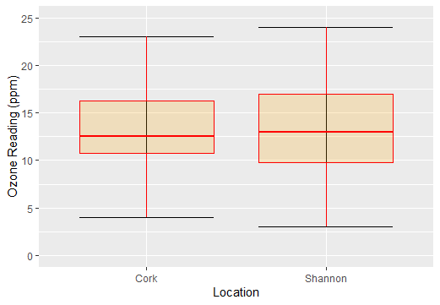

**Descriptive statistics and normality**

Using summaries ()

|  |  |  |
| --- | --- | --- |
| Statistics | Location | |
| Cork | Shannon |
| Sample size | 20 | 20 |
| Mean | 13.40 | 13.05 |
| Standard Deviation | 5.195139 | 5.165421 |
| Median | 12.5 | 13.0 |
| 1st quartile | 10.75 | 9.75 |
| 3rd quartile | 16.25 | 17.00 |
| Min | 4 | 3 |
| Max | 23 | 24 |

**Histogram**

